

FindMe Specification & Design

Date: April-14-2014

Version: 3.0

Authors: Chiranthan Mirle - 1001011399

Abhishek Agarwal - 1000987331

Ranjith M A - 1000969864

Ather Mohammed - 1000993284

Bhavana Nandyala - 1000859140

Document History

#### Version History

|  |  |  |
| --- | --- | --- |
| **Version Number** | **Version Date** | **Summary of Changes** |
| 1.0 | 2-24-2014 | Draft |
| 2.0 | 3-24-2014 | Review & Addition of contents |
| 3.0 | 4-14-2014 | Review & Addition of Contents |

TABLE OF CONTENTS

1. Purpose 4

2. Inputs & OUTPUTS 4

3. DATA STRUCTURES…...…………………..…...…………………….5

4. USE CASES & DIAGRAMS 5

1. **PURPOSE OF THIS DOCUMENT**

The main purpose of this document is to describe the design details of FindMe Mobile application. Our android application enables the user to locate a building or find his/her friend. Main users of this android application will be UTA new students and visitors. In this document we are describing the inputs & the outputs, the data structure used and use cases.

1. **INPUTS & OUTPUTS**

**Application Inputs:**

* **USER LOGIN:**

1. Log with Facebook
2. Login with email Id

For the user to use the FindMe application he has to enter his/her. He can login through either Facebook or Email ID. If the user doesn’t have a Facebook account he can login through his email ID. If the login is through facebook, authentication is done by FB authentication system else the user credentials will be stored in the database and authenticated using the database residing on the omega server. In this latter option, the new user should enter his particulars and a new password, which would be stored in database.

* **FIND BUILDING FEATURE:**

Select the Building category, submit and choose the desired building from the list.

After successfully logging in, the user can find any building under different categories like administrative, sports, food court etc which can be seen in the drop down menu (Spinner). So, the user has to first select the building category of the building he is looking for and then the building.

* **FIND FRIENDS FEATURE:**

Enter the Friend’s name

After successfully logging in, if the user wants to find a friend, he should enter his username, upon that a request will be sent to his friend asking him to acknowledge. After his friend acknowledges, Distance will be calculated and displayed along with the direction.

**Application Outputs:**

* An arrow which directs us to the desired building or a friend along with the distance from it.
* After the user logs in he can choose to find a building or friend based on his requirement.

1. **DATA STRUCTURES**

* We are creating a database table on omega server that stores for each user the user's name, password, email address and Phone number for authentication purposes.

1. **USE CASES & DIAGRAMS**
2. **FIND BUILDING**

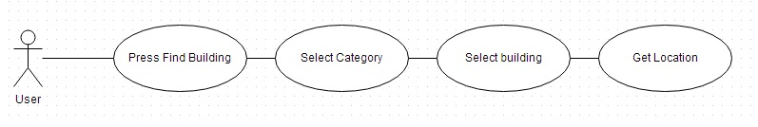

**Level:** User goal

**Main Success Scenario:**

* User clicks on Find building button
* User selects the category of the building to be searched.
* From the list, choose the desired building.
* The distance and direction to the destination is displayed on the screen

**Extensions:**

* The GPS accuracy decreases drastically, then there is an alert message that accuracy is low
* User might search for the desired building in the wrong category

**Special Requirements:**

* Sensors
* Outdoor user

**Open Issues:**

GPS is inaccurate indoors.

1. **FIND FRIEND**

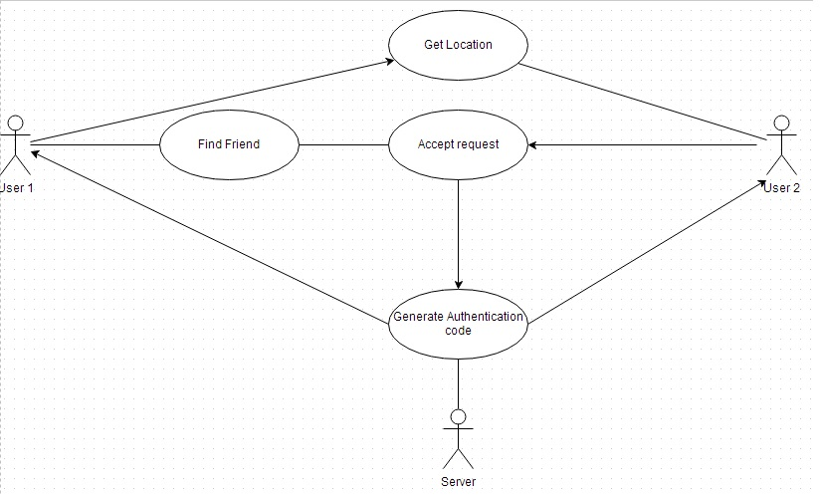

**Level:** User goal

**Main Success Scenario:**

* User clicks on Find friend button
* User searches for the friend
* User sends a request to track friend
* Friend accepts the request to track
* The distance and direction to friend is displayed on the screen

**Extensions:**

* The GPS accuracy decreases drastically, then there is alert message that accuracy is low
* User may not be able to find friend

**Special Requirements:**

* Sensors
* Outdoor user

**Open Issues:**

GPS is inaccurate indoors

1. **LOGIN THROUGH FACEBOOK**

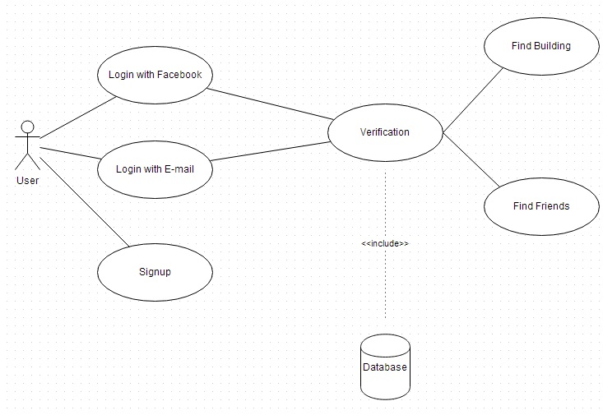

**Level:** Requirement goal

**Main Case Scenario:**

* User clicks on Login with Facebook button
* User enters his/her credentials
* User logs in successfully

**Extensions:**

* User may enter wrong credentials
* Facebook server is down

**Special Requirements:**

Internet connection

**Open Issues:**

No internet connectivity